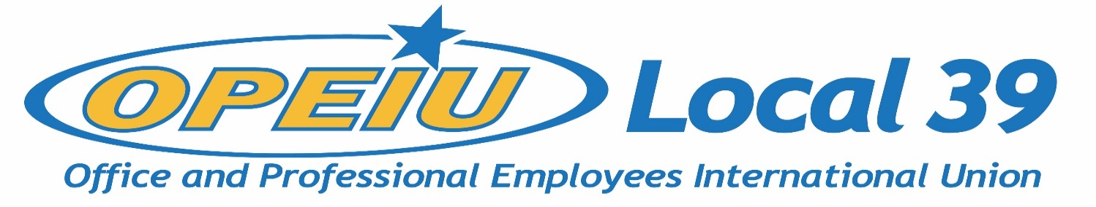

Membership Update
February 17, 2021

Overall Membership Numbers by Year (as of 12/31)

Year | # of Members
2015 | 796
2016 | 768
2017 | 702
2018 | 750 (merger w/L95)
2019 | 721
2020 | 650

Membership by Unit (as of February 5, 2021)

Unit | Members | Non-Dues Paying EE’s
Aspirus Riverview Hospital | 19 | 5
CUNA Mutual Group | 429 | 41
CUNA Inc. | 23 | 23
Madison, Gas & Electric | 85 | 1
Domtar Paper | 12 | 0
IBEW Local 14 | 1 | 0
IBEW Local 953 | 2 | 0
IBEW Local 965 | 1 | 0
Iron Workers Local 383 | 1 | 0
NCSRCC | 8 | 0
NCSRCC Training Fund | 4 | 0
NECA-IBEW | 2 | 1
OPEIU Local 39 | 3 | 0
Operating Engineers Local 139 | 4 | 0
South Central Federation of Labor | 1 | 0
Sheet Metal Workers Local 565 | 1 | 0
Solarus | 17 | 6
Verso Paper | 4 | 0
WEEBF | 7 | 0

