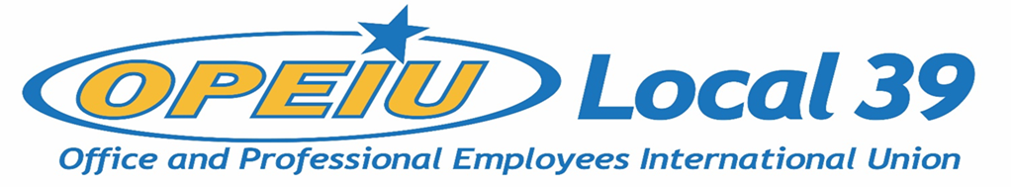

Membership Meeting Agenda
February 17, 2021

Officers
President – Kathryn Bartlett-Mulvihill (OPEIU L39)
Vice President – Tyler Albrecht (CMG)
Secretary Treasurer – Lori Richardson (IBEW L 965)
Recording Secretary – Kelsey Hahn (MG&E)
Trustee 1 – DeAnna Braaksma (CMG)
Trustee 2 – Mike Pionke (CMG)
Trustee 3 – Nicole Scheidegger (MG&E)
Trustee 4 – Kelly Halverson (Solarus)
Trustee 5 – JoAnn Hake (Verso Paper)
Trustee 6 – Debi Eveland (OPEIU L39)

Units
CMG Aspirus Hospital
CUNA Inc. Solarus
MG&E Domtar
ND Paper Sheet Metal Workers L-565
NCSRCC IBEW 965
Verso IBEW 953
NCSRCC Training Fund WEBBF
SCFL Operating Engineers L139
Sonoco IAMAW District Lodge 66
NECA – IBEW NCSRCC
Iron Workers L-383 IBEW 14

Agenda
- Approval of Membership Meeting Minutes – November 18, 2020
- Membership Update
- Business Rep Reports
- Financial Reports
- Communication Update *Motion (see below)
- Old Business
1. Constitutional Changes
2. Dues Referendum
- New Business
1. Dues Referendum – Vote Certification Committee

Motion Approved February 10, 2021 by OPEIU L39 Executive Board
The executive board proposes to postpone the membership vote on changes to the constitution, which was to take place on February 17, 2021, until the dues referendum is complete. The dues referendum will take place beginning February 17, 2021, with voting to be closed March 3, 2021. Once this dues referendum is complete, the executive board will propose an amendment (see 2009 Constitution Article 26) to amend Article 12, section 1A, to better define language relating to the dues policy. This constitutional amendment will be presented to membership at an upcoming special meeting.

