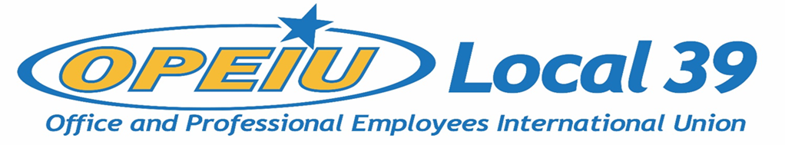

Membership Meeting Minutes
November 18, 2020
____

5:30 PM – GoToMeeting

Officers
President – Kathryn Bartlett-Mulvihill - present
Vice President – Tyler Albrecht - present
Secretary Treasurer – Lori Richardson - present
Recording Secretary – Kelsey Hahn – present
Trustee 1 – DeAnna Braaksma - present
Trustee 2 – OPEN
Trustee 3 – OPEN
Trustee 4 - OPEN
Trustee 5 – Kelly Halverson - present
Trustee 6 – Debi Eveland - present

Units
CMG Aspirus Hospital
CUNA Inc. Solarus
MG&E Domtar
ND Paper Sheet Metal Workers L-565
NCSRCC IBEW 965
Verso IBEW 953
NCSRSS Training Fund WEBBF
SCFL Operating Engineers L139
Sonoco IAMAW District Lodge 66
NECA – IBEW NCSRCC
Iron Workers L-383 IBEW 14
La Casa Norte - new

General Business:
• Approval of Membership Meeting Minutes – August 19, 2020 - approved
• Secretary-Treasurer’s Report - given
• Updates from Units
- Geoff Guy, La Casa Norte steward, new unit – won at 75%.
- Nicole Scheidegger, MGE chief steward – COVID leave negotiations, system upgrades & vacation impact.
- Sue Glodowski, ND Paper – internal restructuring, other unions also negotiating. Changes in actual work performed by members.
- Kathryn re: mills – already struggling & worse with COVID, Verso closure
- Dee Braaksma, CUNA Mutual – contract extension approved through March 2022, +92% voted to approve w/80% participation. Company cooperating with COVID coverage, extended through March 2021. Contract extension will let us better address issues.

New Business:
• Constitution Updates
- Not a huge number of changes – articles V, VIII, XII.
  - Article V – longer language, updates per international, hasn’t been changed in a decade. Same general principles.
  - Article VIII – went from 5 trustees + member at large, to 6 trustees
  - Article XII – dues structure – see below.
  - Available on website for review
• Change to Dues Structure – Flat to Percentage Based Dues
- 2019 convention voted to mandate change from flat rate structure to percentage
- Since L95 merger, we have had two sets of dues rates, single $46.50 rate in Madison and range $32.50 - $44.50 in former L95 area. DOL requires a uniform rate across all members and we need a consistent structure to ratify constitution
- Equity – lowest wage workers pay a higher percentage of wages towards dues than higher wage workers do – want to level the playing field
- Current income does not cover expenses – need to increase budget
- Board approved 1.25% with $90 cap (cap to increase $1/yr.)
- Would like to hire admin staff part time
- Flat structure not equitable – lower wage members pay a larger percentage of their wages towards dues than higher wage. Percentage basis makes it so that lower paid workers no longer shoulder the greater burden.
- If approved in February, we need to implement with employers – probably not implemented until Q2 2021
- Membership concerns (starting 6:27 PM)
  - comparisons to healthcare, gym membership as flat fees
  - is there a backup plan to meet budget needs if enough people opt out of paying?
    - Some built-in cushion on budget; ultimately if enough people opt out the union will cease to be. A big structural change that is not without risks
    - If this is voted down, we can reassess; worst case is trusteeship by international, could be merged into another local (loss of local control)
  - Adrienne – service model vs. organizing model: the union isn’t just a service; the members are the union.
  - Kelsey – comparable flat rate to meet budget needs would be ~$70/month, 4% for Aspirus etc.
• Motion to move votes for these changes forward – approved. Voting will take place prior to February 18, 2021 membership meeting; ballots will be mailed to members’ homes. Looked into digital options (ElectionBuddy etc.) but not approved by DOL – could use ElectionBuddy’ s mailing service if cost effective, potentially deliver ballots electronically (but would need to be returned by mail)

Adjourn 7:09 PM

